MailingAddress

Dear FullName,

Invoice Sunday, February 13, 2011

On behalf of Rabbi Weinberger and Congregation Shomrei Torah of Passaic Clifton, I would like to express my sincere gratitude and appreciation for your financial support and valued participation in our davening and learning. Through your generosity, support, and participation our Shul will continue to grow and thrive as a special place of Torah and Avodah.

Your total balance due is BalanceDue. Please review the summary below. If you have any questions regarding the pledges or payments contained herein, please email [Billing@ShomreiTorah.us](mailto:Billing@ShomreiTorah.us) or contact Levi Krinsky at (973) 594 – 7972.

Thank you.

Table

PayToSincerely,   
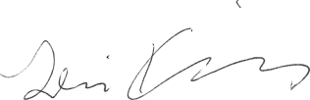  
Levi Krinsky

Treasurer